**Sprint - 4**

|  |  |
| --- | --- |
| Date | 18 November 2022 |
| Team ID | PNT2022TMID51214 |
| Project Name | Project – Smart Farmer - IOT Enabled Smart Farming Application |

Node – Red Configuration & Sending Commands To Motor :

* We Added Two Buttons In The Application In Order To Access The Motor

**1** = Motor On

**0** = Motor Off

* We Used A Function Node To Analyses And Receive And Analysis Of Data The Node – Red Code :

**if(msg.payload===1)**

**msg.payload={“command”:”ON”}; else if(msg.payload==0)**

**msg.payload={“command”:”OFF”};**

**JSON UI Interface:**

1. In order To Use A Virtual Environment We Can Develop A Platform In Node

– Red In Order To Show The Gauges, Text And Buttons To Control The Equipments.

**Node – Red Platform:**

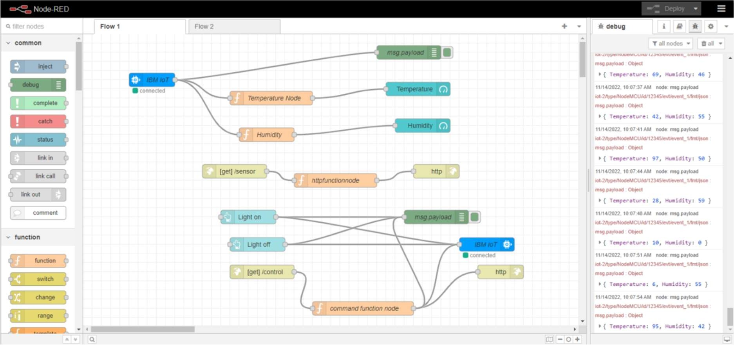

**Screenshot (Gauge, Text And Button):**

